How to participate in Televisits with miCare through Patient Portal

The first step is to call and schedule it with your provider
Before beginning your TeleVisit, make sure that you:
1.) Have access to a computer/laptop, with a camera and GOOGLE CHROME browser
2.) Have an active Patient Portal account, with username and password
3.) Set aside a secure, private location

To begin your Televisit, follow these easy steps:

- “Arrive early” by clicking “Join this Telemed Appointment directly” in your emailed appointment reminder. 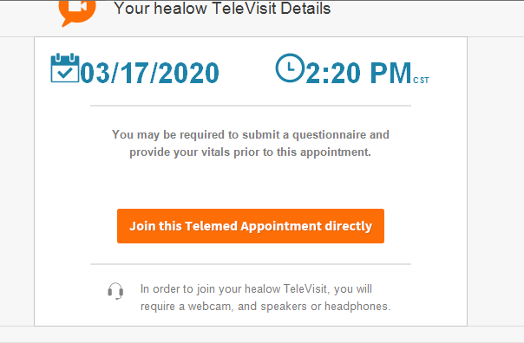
Or by accessing your Patient Portal Online at health.healow.com/miCare and selecting “Join Televisit” On your patient Dashboard
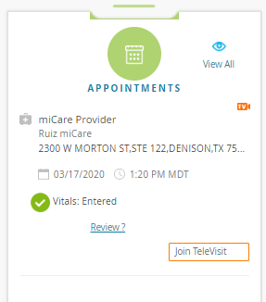

- Fill out any vitals that you have available and select “Submit Vitals” or select “Skip” to move on.
- The system will check your computer’s speed and ability to support a TeleVisit. If your computer does not have a webcam (most do), you will need to attach one.
You will see all green check marks when you are ready to move on.
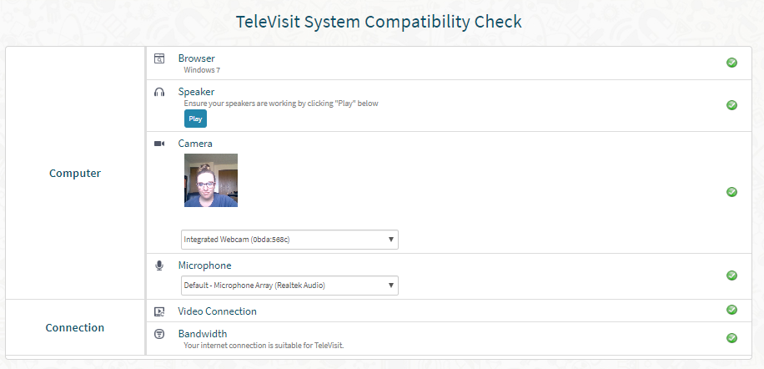
- Click “Proceed” to enter the virtual waiting room.
- Your physician will begin the face-to-face TeleVisit, and disconnect when the visit ends.

***If you experience any technical problems or have questions about the TeleVisit process, first look at the TeleVisit help file at the bottom left on your Patient Portal. If you still need additional help, we offer free, live chat support, accessible at the bottom of the TeleVisit help page.

