How to participate in Televisits with miCare through Healow App

The first step is to call and schedule it with your provider

Before beginning, you must have access to the miCare Healow App and have an account setup.

To begin your Televisit, follow these easy steps
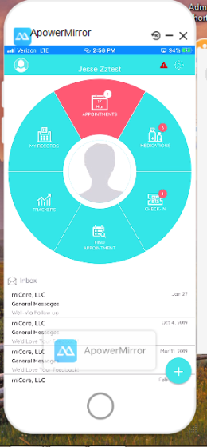
1. “Arrive early” by opening up your Healow App and selecting the RED “Appointments” Icon at the top
2. Select the eye Icon to the right of the screen
3. Select “Start Televisit” at the bottom of the screen
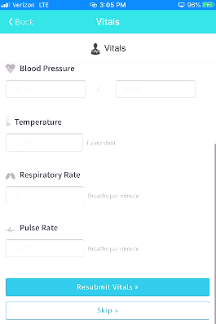
4. Enter vitals and scroll down to “Submit Vitals” or “Skip”

5. Click “Start Televisit”
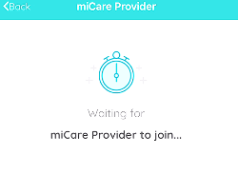
6. Your physician will begin the face-to-face TeleVisit, and
disconnect when the visit ends.

