CUSD MIGRANT EDUCATION PROGRAM
Department of Supplemental Services

“Children Are Our Most Precious Resource”
Purpose of Migrant Education Program: CUSD Migrant Education Programs supports high-quality and comprehensive educational programs for migratory children to address disruptions in schooling and other problems that result from repeated moves. States fund programs that ensure migratory children are provided with appropriate educational services (including supportive services) that address their special needs in a coordinated and efficient manner. The programs help ensure that migratory children have the opportunity to meet the same challenging State Content Standards and student performance standards that all children are expected to meet. They are also designed to help migratory children overcome academic, cultural, and language barriers, social isolation, health-related problems, and other factors that hinder academic achievement. They prepare the migratory children to make a successful transition to postsecondary education or employment; and ensure that they benefit from state and local systemic reforms.
Academic Services:
The Migrant Education Program (MEP) supplements the regular school program by helping migrant students sharpen their academic skills, assists them in becoming proficient in the core content areas, and provides them with an opportunity to participate in enrichment programs that otherwise would be unavailable. Services include: academic assistance, tutoring, after school programs, dropout prevention, parent/teacher consultations, monitoring of student grades and attendance, a library for checking out books and materials for students and parents. Children may qualify for tutoring in reading and/or math if they are working below grade level. For more information please contact your child’s school or the Department of Supplemental Services at 327.9564.

Who are our Migrant Workers? According to Sections 1309 and 1115(b)(1)(A) (which applies by reference) of the statute and 34 CFR 200.40(c) and (e) of the regulations, children who are migrant and have had the basis for their MEP eligibility are properly recorded and may receive services. Migrant workers seek temporary or seasonal work in agriculture, fishing, or related industries, including food processing. They follow the growing seasons across the country and are largely responsible for the cultivation and harvest of fruits, vegetables, and many other food products. Many migrant workers have an average income below the national poverty line. While many migrant families consider California to be their home base, others come from other states and countries.
- (a) Is younger than 22 (and has not graduated from high school or does not hold a high school equivalency certificate), but (b), if the child is too young to attend school-sponsored educational programs, is old enough to benefit from an organized instructional program (Section 1115(b)(1)); AND
- Is a migrant agricultural worker or a migrant fisher (as defined in Section 1309 of the statute) OR has a parent, spouse, or guardian who is a migrant agricultural worker or a migrant fisher; AND
- Performs, or has a parent, spouse, or guardian who performs, qualifying agricultural or fishing employment as a principal means of livelihood (34 CFR 200.40(c), (e), and (f)); AND
- Has moved within the preceding 36 months to obtain, or to accompany or join a parent, spouse, or guardian to obtain, temporary or seasonal employment in agricultural or fishing work; AND
- Has moved from one school district to another.

Through the Migrant Education Program, these children can be provided with supplemental educational and support services to help overcome their difficulties. Migrant children can close the achievement gap in education and develop skills and options for the future. In addition, the program provides opportunities for them to develop self-confidence and self-esteem.
What Makes a Child Eligible? To qualify for the Migrant Education Program, a migrant child must have moved within the past three years across state or school district boundaries with a migrant parent, guardian, or self, to enable the child, the child's guardian, or a member of the child's immediate family to obtain temporary or seasonal employment in an agricultural, fishing, or food processing activity. The child may be in any grade between preschool and the 12th grade and must not be older than twenty-two and has not received a diploma or GED.
CUSD HEALTH SERVICES:
Each CUSD School has a nurse who can assist with any questions or concerns. We also offer two health clinics throughout our district to assist families with a variety of health needs. For additional information, please call the health clinic closest to your child’s site.

CUSD CHILDREN’S HEALTH CENTERS
Appointments are recommended, but not required.
Patients without an appointment are seen on a FIRST COME, FIRST SERVE BASIS.

Sierra Vista Elementary 327-7976 8:30-12:00, 1:00-4:00, Monday – Thursday*
*Closed for lunch between 12:00-1:00

Fee schedule (CASH ONLY):

Well-baby care and well-child care

Immunizations – Call for fees
PPD skin tests are $10—(skin tests are given on Monday, Tuesday or Wednesday ONLY)
WIC referrals
Treatment of minor injuries and illnesses
Sports screenings & Preschool/1st Grade physicals--$30
Assistance in signing up for Healthy Families or Medi-Cal insurance programs
The services are available to children ages 0-18 years and are free of charge to income-eligible families. Patients who have Medi-Cal are also eligible for these services as well as those who do not have health insurance coverage.

Department of Supplemental Services Team:
●Ana Macias, Community Liaison Spanish @ 327.9564
●Mary Vang, Community Liaison Hmong @ 327.9560
●Tam Tran, Program Technician @ 327.9554
●Bob Kampf, Director @ 327.9086
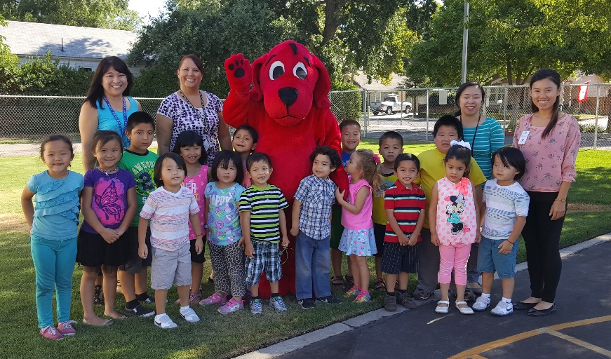

Clovis Pre-K Summer Readiness Program 2016
Weldon Elementary School

