Library Policies
CHECK-OUT
Students in grades 2nd-6th are allowed to check out 2 books at a time, for 2 weeks at a time. Books may be renewed one time before the due date. Grades TK-1st may check out 1 book at a time, for 1 week at a time.
Lost or Damaged Books
https://clovisusd.revtrak.net
Pay Lost/Damaged Library Books and Textbooks Fines Online!
We understand that library books and textbooks can get lost or damaged beyond repair.
If a book is lost, or damaged beyond repair, the student will be responsible for a
replacement of equal quality. This includes books that have been left in the rain, eaten
by pets or siblings, crushed or broken bindings in a desk, etc.
Copper Hills will accept a replacement copy of a book or a revtrak payment.
Please contact the library for further information.
If you choose the replacement option the replacement copy needs to be hardbound,
preferably a library binding. Many times these can be found on Amazon.com or
Thriftbooks.com OR You pay for the book through revtrak online.
Click the following link to make a payment online: https://clovisusd.revtrak.net

Over Due Books
All books are checked out for two weeks. Overdue notices are sent out monthly. Students have 10 days to return a past due book.

What is Accelerated Reader (AR)?
- AR is a computer program that quizzes your child on a book they have read.
- Your child picks a book at his or her own level and reads it at his or her own pace.
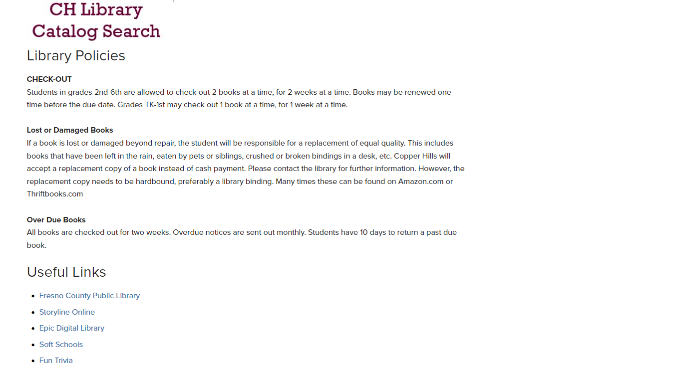
- When finished, your child takes a short quiz on the computer.
