Online Course Request process through Student Connect – 2020-2021

Each Grade Level student will have a Course Request time frame window to Add or Delete their Course Requests online utilizing Student Connect. Students will also turn in a Course Request form to their counselor on their assigned date.

To complete the online Course Request students will:
Log in to your Student Connect account.
If there are 2 School Year choices- choose next school year (2021-2022).
On the left side of the screen choose “Requests”.
Click on Add/Edit Requests at the top right-hand side under the Requests tab.

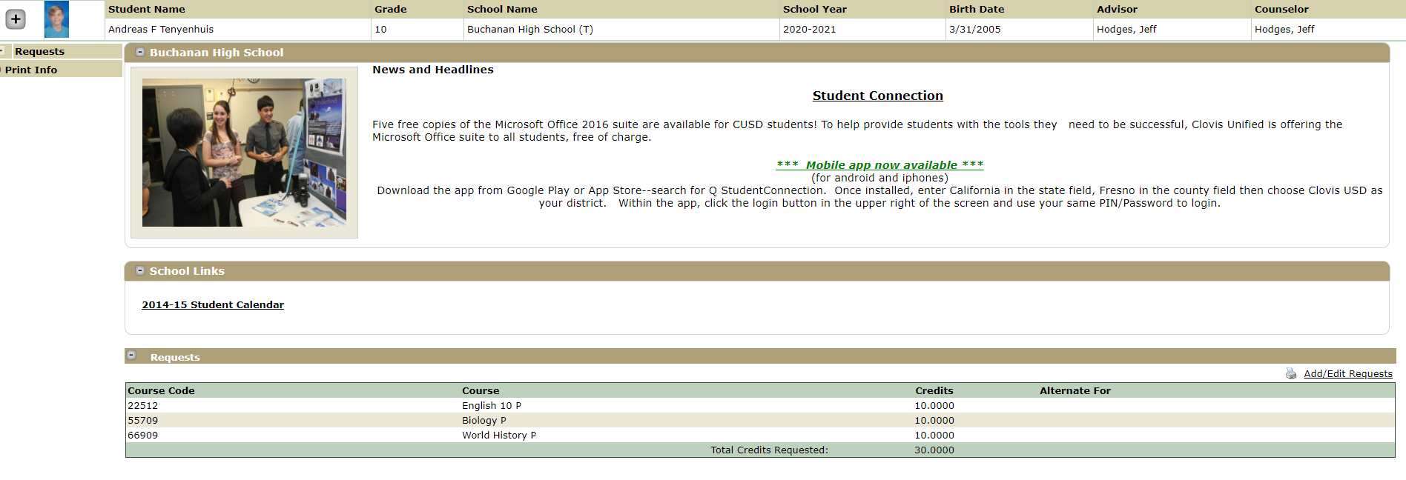
Pre-Loaded Course Requests for that school year will be at the top. You will not be able to alter these requests, but you can Add or Delete other courses you choose and assign an Alternate for a Pre-Loaded Course Request. (Note- this picture shows an X next to all courses, but for 2021-2022 school year Pre-Loaded Course Requests will not have an X).
To Add a Request- You can leave “All” in the Subject box and scroll through all of the courses or you may select a school subject from the drop-down window in the Subject box to narrow your search. Find the class and double click to pull it over to the right side. Click on Add Selected Course.

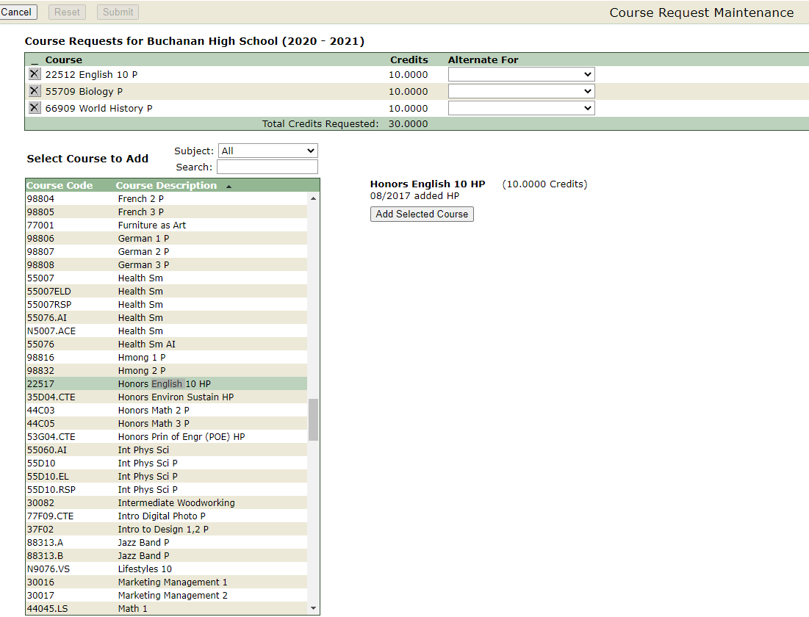

If this class is an Alternate for a course that has already been added (Pre-loaded or by you) then utilize the drop-down window under “Alternate For” to select which class it is an alternate for- (i.e. Honors English 10 is an Alternate For English 10 ). When finished click Submit (next to Updates Pending) to save that course.

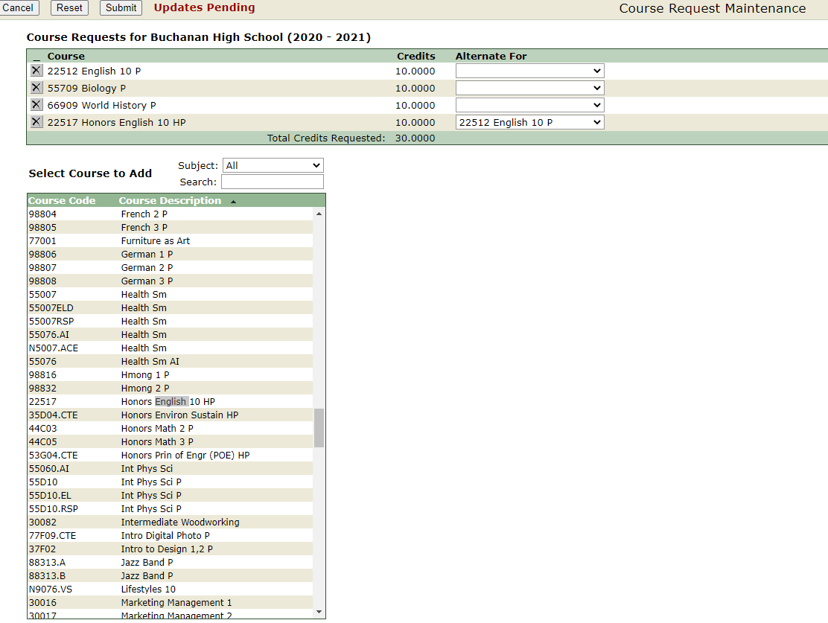
Summer School request- If need summer school, make sure to add to your Course Request form. Indicate class requesting for summer school and the class you plan to take during the school year to replace that class (NOTE: 3.0 GPA is required and Impacted Schedule). In Requests on your Student Connect follow the steps above utilizing the “Alternate For” drop down window (i.e. Freshman- Orchestra is the Course Request, Health is the “Alternate For”.
Freshman- “Alternate For” is Health
Sophomore- “Alternate For” is World History, PE Core or Chemistry (for AP Biology)-talk with Counselor
Junior “Alternate For” is U.S. History
Senior-(typically) No “Alternate For”- talk with Counselor

To Delete a Course Request – that you have entered you can click on the X to the left side of the course. Remember you will not be able to delete Pre-Loaded requests, so if you would like to change a Pre-Loaded course utilize the steps from above using the “Alternate For” feature.
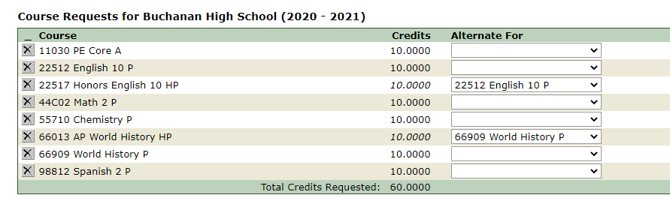
When you are satisfied with your course selections make sure to hit the Submit button if there are “Updates Pending” or you will lose all of your choices you have made.
If you still have time in your Course Request Window time frame you may repeat the above steps as many times as you want, but make sure to hit the Submit button when complete.
When you meet with your Counselor on your assigned day through your English class (or during a make-up day), your counselor will review your choices you have made. Changes can be made at that time by your counselor since you will have been locked out of the Course Request selection process (end of the Course Request Window). Students will also need to have completed and turned in their grade level Course Request Form that had been sent out prior to this day.

