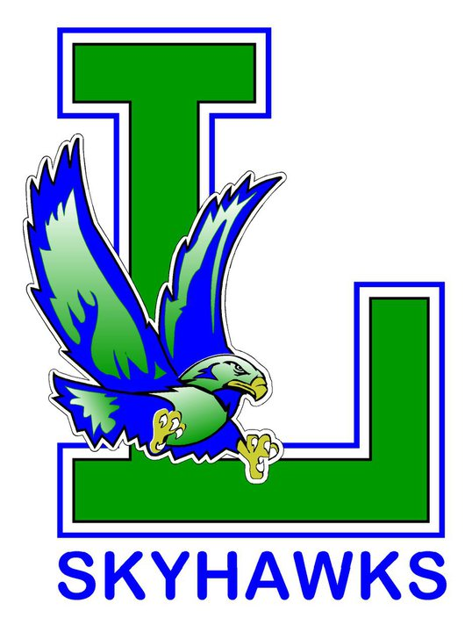
Liberty Yearbook 2022-2023
Order Form
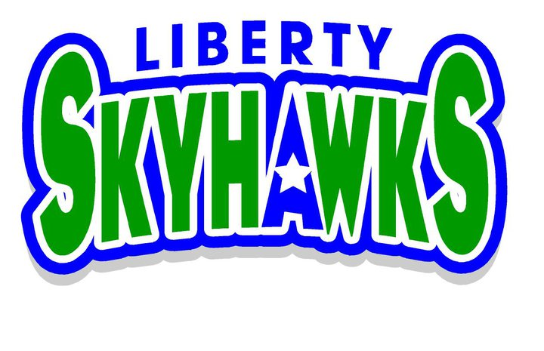

$30 Each- EXACT CASH ONLY

Yearbooks are now on sale and are available by preorder only! Please return order form and cash payment by Friday, March 31st. Books will be passed out to your child during the last week of school. Please submit one form per family.

Child’s Name: | Teacher: | Amount Due ($30 per book):
1.
2.
3.
 | Total Cash Payment Due by Friday, March 31st | $

Questions: Contact Mrs. Curtis at LoriCurtis@cusd.com

********************************************************************************************************
For Office Use Only:

Deposit Date: _____________ Cash Amount: _____________ Notes: ______________________________

