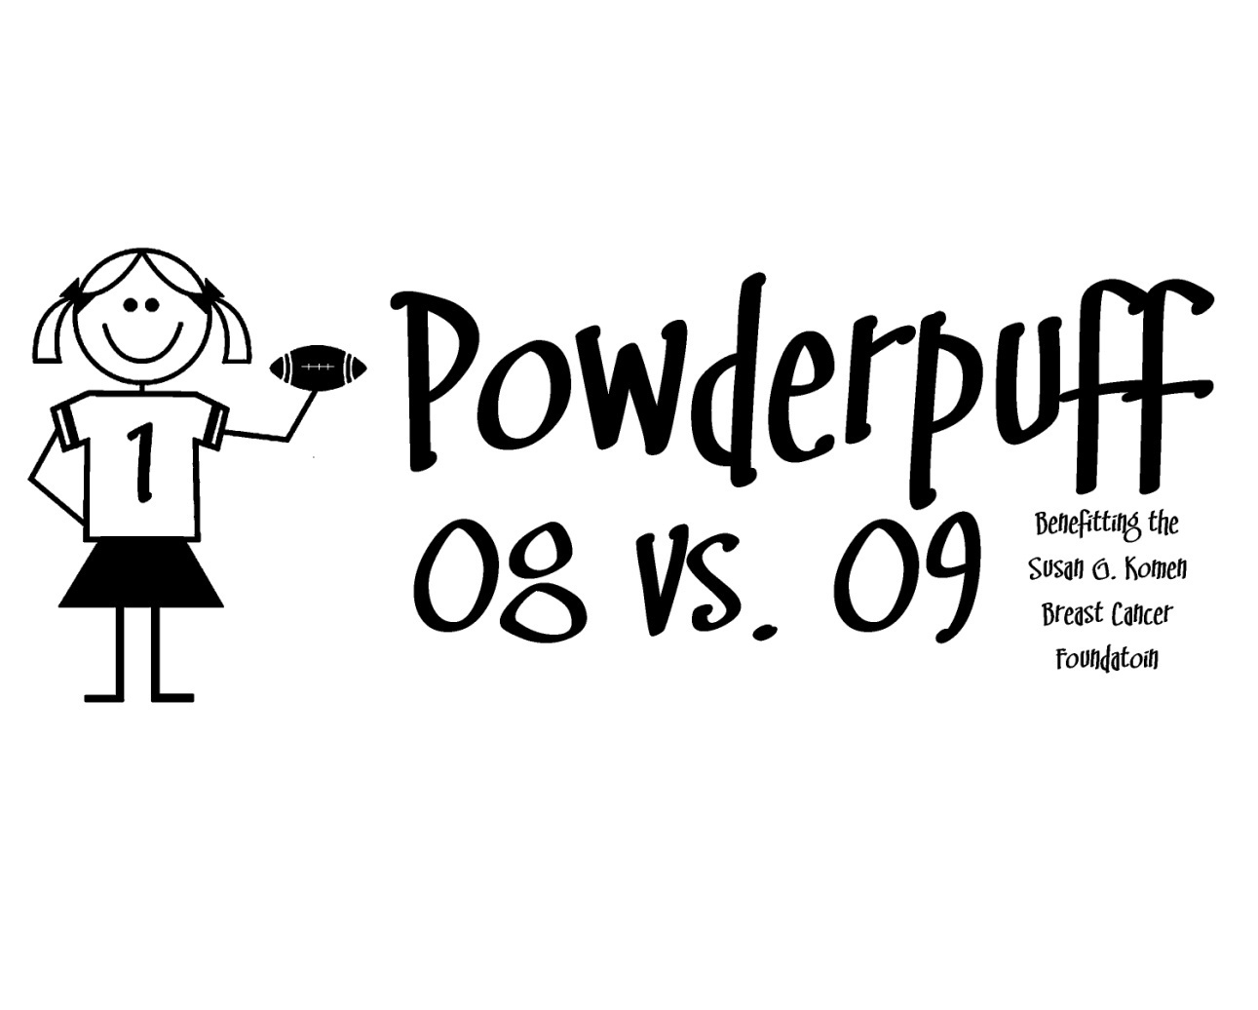

Powder Puff Football

’20 VS ‘21

**Thursday, December 19th, 2019**

**6:30 pm**

**Frosh Football field**

A $10.00 non-refundable donation is asked to cover cost of shirt and supplies.

Packets due to Activities office on Friday Dec. 6th

(Signed parent permission slip, emergency info, $10.00 donation;

**checks made payable: Foundation West – Activities**)

All **5** practice dates and rules to participate are attached

Activities office will collect all money for shirts. (Students are not to collect money)

Student coaches must complete permission slip and emergency form

***Turn in waiver and money to the Activities Office***

***no later than Friday, Dec. 6th***

|  |  |  |
| --- | --- | --- |
| Date of Practices | Location of Practice | Time |
| Tuesday, Dec. 10th | Frosh Fball Field /  Behind East Gym | 5:30-6:30 pm |
| Thursday, Dec. 12th | Frosh Fball Field /  Behind East Gym | 5:30-6:30 pm |
| Monday, Dec. 16th | Frosh Fball Field /  Behind East Gym | 5:30-6:30 pm |
| Tuesday, Dec. 17th | Frosh Fball Field /  Behind East Gym | 5:30-6:30 pm |
| Wednesday, Dec 18th | Frosh Fball Field /  Behind East Gym | 5:30-6:30 pm |
|  |  |  |
| **GAME:**  Thursday Dec. 19th | FROSH FOOTBALL FIELD | Arrive at 5:30 pm |

**Practices:** For all players and cheerleaders

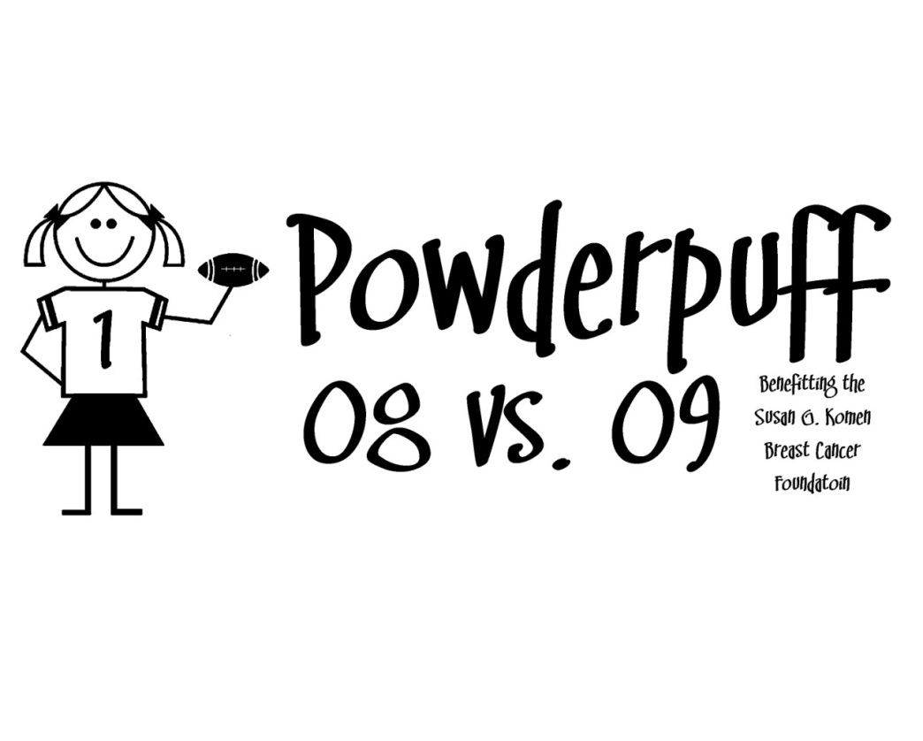

**POWDER PUFF GAME RULES**

Behavior

* Good sportsmanship must be displayed at all times by both players and coaches (i.e. inappropriate language)
* Participants must behave in a respectful manner with all adults and supervisors
* Foul play is not allowed (no tackling, punching, scratching, hair pulling etc.) Participants who behave inappropriately will be immediately removed from the game and may face suspension or other disciplinary action outlined in the student handbook.

Time

* Junior /Senior game

-Halves are 20 minutes running time unless possession changes or a penalty is called

-Half time will be 8 minutes

-Offense has 30 seconds to huddle **with coaches** and begin the next play

Uniform

* No jewelry (earrings may be covered or taped)
* All players must use Powderpuff shirt and flags
* Hair must be pulled back into a pony tail and out of the face
* No cleats are allowed

Kicks

* Offense may punt if they have not moved 10 yards within 4 downs
* No roughing the punter
* If you say you are going to punt, you have to do it. You must tell the referee if you are going to punt
* The punting team cannot leave the line of scrimmage until the ball is kicked
* The punt receiving team must have at least six (6) people on the line
* On-sidekicks are not allowed
* For run backs of punts and kick offs, the ball is dead when it hits the ground. Play will begin from where the ball first hits the ground or the 20yd line if it goes in the end zone
* Interceptions are legal. If the interceptor is not wearing flag, then the ball is dead, but the interceptor’s team gets the ball

Illegal Actions/Penalties

* Off-sides, illegal motion, false starts
* No running people over
* Any intentional foul is cause for ejection
* Blocking arms must stay extended and cannot reshoot them
* Flag guarding (flags must be worn OUTSIDE the jersey)
* Clipping (blocking from behind)
* Pass interference
* Offensive holding
* Tackling (if the official thinks you were trying to knock someone down, it is a penalty and a possible ejection from the game)
* Too many players on the field
* Throwing a pass after you’ve crossed the line of scrimmage (pitching **backwards** is allowed)
* No pushing out of bounds
* No below the waist blocks
* Coaches and players who talk back will be excused from the game

Other Important Rules

* Offense has 30 seconds from the time the previous play ends until the next one starts—two (2) coaches may be on the field to give plays, but offense only has **30 seconds** to resume play.
* Intentional grounding is illegal
* Each team gets two (2) time outs per half (time will stop for time outs. Time outs will be one (1) minute)
* Anyone who uses foul play or unsportsmanlike conduct on either side will be immediately ejected out from the game.
* Extra point(s) after touchdowns- No field goals. A successful play (touchdown) from the 5 yd line will be awarded one point. A successful play from the 10 yd line will be awarded 2 points.

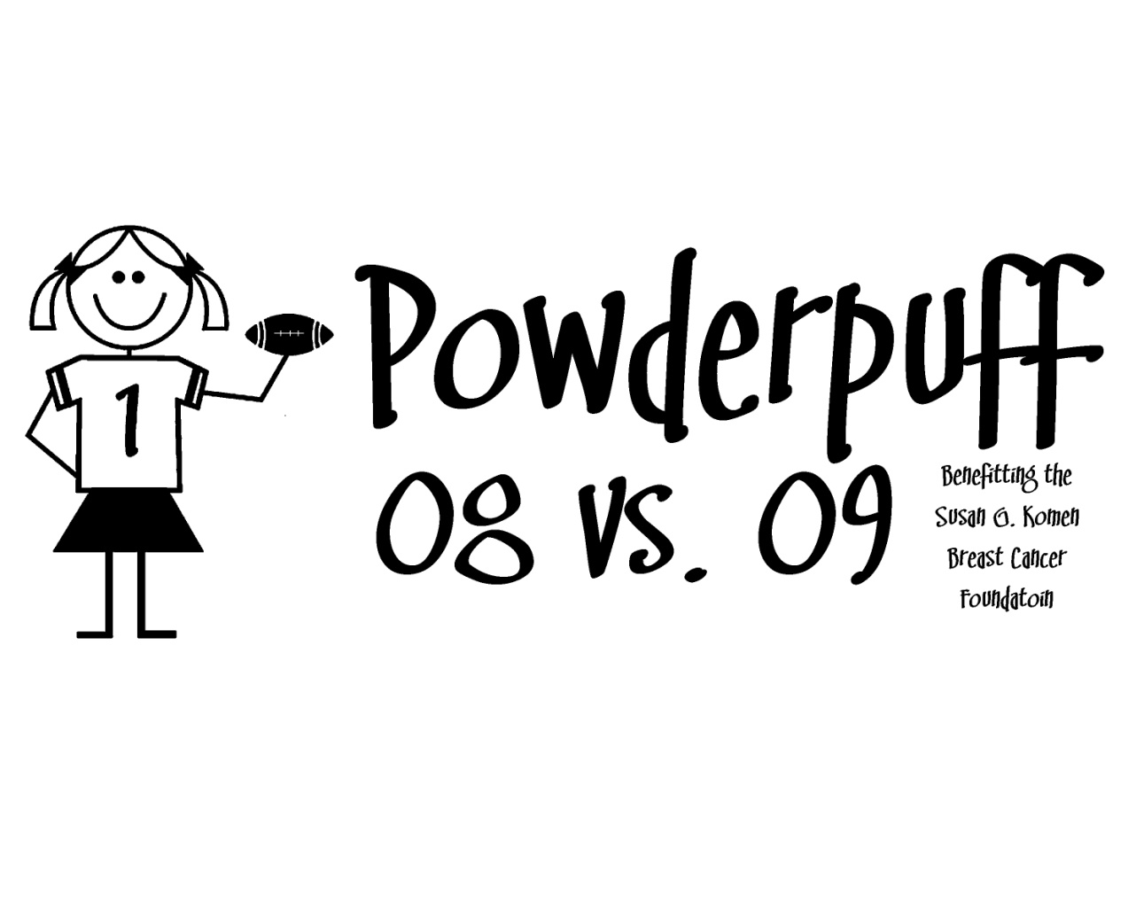 Powder Puff

Football

Participation Application

Senior Class of 2020 **vs.** Junior Class of 2021

My son/daughter, ____________________________, has permission to participate in the Clovis West powder puff football game on **December 19th at the Frosh Football Field**. In addition he/she has permission to participate in all practices as well. By signing below I acknowledge the following. I acknowledge that while this is flag football, there will still be contact and with any physical activity there is in inherit risk of injury. I further acknowledge as the parent/guardian of the student identified above that as provided in California Education Code Section 35330, I agree to waive all claims against the Clovis Unified School District (District) and hold the District, its officers, agents and employees harmless from any and all liability or claims which may arise out of connection with my child’s participation in this activity.

The participant may be exposed to the following high risk activities during this field trip/activity: _while this is flag football, there still will be physical contact from playing.

Students Name: _________________________________

I hereby authorize the above-named individual to participate in the activity outlined above. In the event of illness or injury, I do hereby consent to whatever x-ray examination, anesthetic, medical, surgical or dental diagnosis or treatment and hospital care and transportation considered necessary in the best judgment of the attending physician, surgeon, or dentist and performed under the supervision of a member of the medical staff of the hospital or facility furnishing medical or dental services. I further acknowledge that the District does not provide medical coverage for participants in this activity. I fully understand that participants are to abide by all rules and regulations governing conduct.

**PRINT**

Student Name: _______________________ Student Signature: ________________________

Shirt Size: ____________ Current Grade: ____________ 4th period room #________

Parent/Guardian Name: ________________________ Phone #_______________

Parent/Guardian Signature______________________ Date: _________________

**ACTIVITY EMERGENCY CARD - CLOVIS WEST HIGH SCHOOL**

**Please Print**





Student Name _____________________________________ Sport SID#

Address _____________________________ City ____________ Zip ________ Phone ____________ Cell ___________

Insurance Co. ___________________________________Policy No. _________________Group No. ________________

DOB_______________ Asthma? Yes or No _______ Inhaler? Yes or No ______ Inhaler Type_________

Are you allergic to any medications? Please list ___________________________________________________________

Any other allergies? Please list _______________________________________________________________________

Presently taking any medication? _______________________________________________________________________

Contact Lens? Yes or No ________

Person to contact in case of emergency:

1. ____________________________________Phone Hm. ________________ Wk. ____________ Cell ______________

2. ____________________________________Phone Hm. ________________ Wk. ____________ Cell ______________

3. ____________________________________Phone Hm. ________________ Wk. ____________ Cell ______________

My son/daughter has permission to participate in athletics at Clovis West High School and to travel with his/her team(s) for athletic contests. Should it be necessary for my child to have medical treatment while participating in sports, or on a trip, and if the District is unable to contact me, I hereby authorize Clovis Unified School District personnel to use their judgment in obtaining medical services for my child. **I understand that my child must have medical insurance that provides at least $1500.00 accidental injury coverage.**

**Parent/Guardian: __________________________________________ (*signature required)***